This week in Foundation
w/b 8/9/25

Notices

- Please a eye out for information about our trip to Cogges Farm.

- Please ensure children have waterproofs and wellies in school.

- Please ensure your jumpers are labelled, we have had a few without homes.

Portraits

This week we have all had a go at drawing our own faces. We had to think about what shapes and colours to use. We can already tell we have some great artists in our classes. We hope to have these displayed for you to enjoy very soon.

Our Book this week is

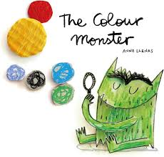

Yoga
On Wednesday afternoon the children all joined in with a Cosmic yoga. We practiced taking our shoes off by ourselves and joining in with the yoga on the screen. All children did so well at having a go at each of the moves.
You could have a go at this at home by searching Cosmic yoga on YouTube.
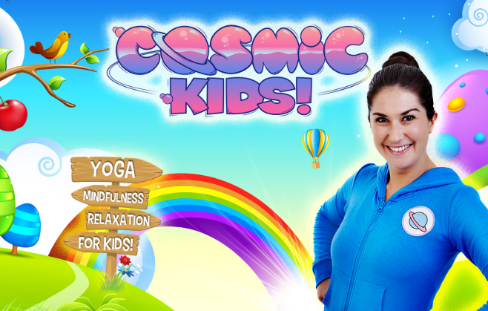
Colour monster
This week we have introduced our first core text. Through this text the children have explored their emotions. We have talked about what each emotion feels like and what we can do when we feel that way.
The children have really engaged in all our circle times taking it in turns to talk and listen to each other.

